Proteins are essential for almost every cellular activity. Their conformational heterogeneity and their ability to visit huge numbers of free energy minima (conformational substates) are the key properties for the understanding of their surprising versatility. While residing in a given structural conformation, they still exhibit a broad spectrum of motions, from local fluctuations of single atoms to structural rearrangements of large extension, with characteristic time spans from picoseconds to minutes. The substates population and the interconversion kinetics among different substates are influenced by the presence of cofactors like, in particular, transition metal ions.

The recent spectacular improvement achieved in X-ray sources brilliance and the increase in the computing performances of parallel supercomputers make today possible to attack structural problems of the highest biological importance that have until now largely defeated the efforts of the scientific community. Among them understanding the phenomenon of protein aggregation is becoming more and more urgent because of its relevance in a vast area of biological researches and applications, ranging from the study of amyloid diseases to the need of better controlling industrial processes like drug synthesis and food preservation.

At the moment the Tor Vergata Biophysics group is strongly focused on the study of the phenomenon of protein aggregation in the presence of metals dwelling on a synergic use of quantum-mechanical simulations to understand the recently available synchrotron- and Free Electron Laser(FEL)-based X-ray Absorption Spectroscopy (XAS) and X-Ray Diffraction (XRD) data.

Indeed, it is generally believed that metals play an important role in the misfolding and aggregation phenomena that lead to the development of neurodegenerative diseases like the Alzheimer's disease (AD) and prion diseases. Metal ions have been found in complex with both β-amyloid (Aβ) peptides and Prion Protein (PrP) that are the main proteinaceous components of the amyloid brain deposition detected in patients.

Relying on a combination of classical molecular dynamics (MD) and ab initio methods, we have studied the influence of the nature of the local physico-chemical environment on the structural features of β-amyloid peptides complexed with Zn(II) ions. The analysis is carried out by comparing among themselves different Zn(II)-ligand force fields and studying their influence on metal coordination and long-range peptide folding. The system in the non-physiological so-called "gas phase" (no solvent) was also simulated with the purpose of identifying to what extent, if at all, the solvent can affect the Zn coordination mode, besides its long-range structural properties. There are two main results of this investigation: i) the Zn(II) coordination mode in classical MD simulations is found to markedly depend on the partial charge attributed to the ion and the atoms surrounding it. In this investigation we have been able to identify the most appropriate Zn(II) force field for the Zn(II)–Aβ_{1–16} complex; ii) although the presence of water obviously influences the peptide folding propensity, it does not affect the structure of the Zn(II) inner coordination shell.

Our group has also carried out XAS measurements on various portions of Prion-protein tetra-octarepeat peptides in complexes with Cu(II) ions, both in the presence and in the absence of Zn(II). Because of the ability of the XAS technique to provide detailed local structural information, we demonstrated that Zn (by directly interacting with the peptide) competes with Cu for peptide binding and viceversa. These finding suggests that metal binding competition can be important in the more general context of metal homeostasis.
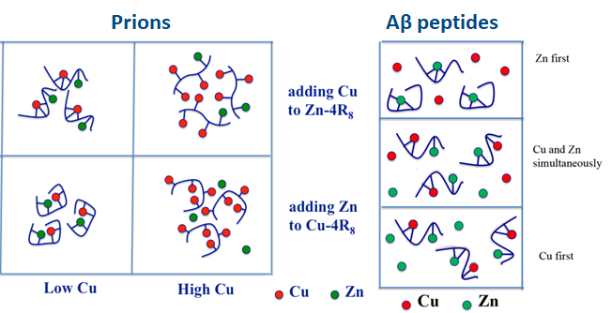
With the aim of finding anti-aggregation oligopeptides with therapeutic effect, we have used extensive molecular dynamics simulations of model systems comprising an Aβ_{1–40} peptide in water in interaction with short peptides (β-sheet breakers) mimicking the 17–21 region of the Aβ_{1–40} sequence. Various systems differing in the customized β-sheet breaker structure have been studied. Simulation results confirm experimental data (thioflavin T fluorescence, circular dichroism, and mass spectrometry), indicating that β-sheet breakers are able to inhibit in vitro fibril formation and prevent the β-sheet folding of portions of the Aβ_{1–40} peptide. Furthermore, far UV circular dichroism experiments suggested by molecular dynamics simulations have provided consistent evidence that a newly devised Ac-LPFFN-NH₂β-sheet breaker is more effective than those known in the literature in stabilizing the native α-helix structure of Aβ_{1–40}. In agreement with these findings thioflavin T fluorescence experiments also confirmed its higher efficiency in inhibiting Aβ_{1–40} aggregation. Furthermore, mass spectrometry data and molecular dynamics simulations consistently identified the 17–21 Aβ_{1–40} portion as the location of the interaction region between Aβ_{1–40} peptide and the Ac-LPFFN-NH₂β−sheet breaker. We have complemented these computational finding with Atomic Force Microscopy measurements.

From the methodological point of view, our group is focusing on the interpretation of XAS data based on ab initio computations and on understanding the radiation-induced changes occurring when exploiting ultra-brilliant synchrotron sources.
On the former side, we have exploited first-principle computations of the low energy part of the XAS spectrum to simulate the spectra of Cu(II) and Zn(II) ions in water solutions and are now applying the same method to study metal-peptide complexes.
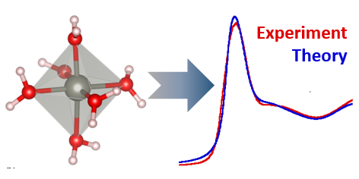
On the latter side, we showed that it is possible to carefully monitor and quantify the level of radiation damage and we prove that at cryogenic temperature the time needed for collecting a good quality spectrum is shorter than the time after which structural damage become appreciable. We are at present working on a theoretical interpretation of this finding.

From a more experimental point of view we are engaged in a collaboration with leading groups in the exploitation of FEL radiation in Biophysics, with the aim of developing new methodologies (in particular in serial crystallography and FEL X-ray absorption and fiber diffraction), instrumentation (designing a beamline for the EuPRAXIA@SPARC_LAB FEL and contributing to define the cientific case of the MariX FEL) and technology (in vivo crystallization) for FEL experiments on systems of biological interest.
